**SL Unit 2** **– Computer Organization**  
Test 1

1. Explain why cache memory can speed up the processing within a computer. [2]
2. Copy and complete the following truth table. [3]

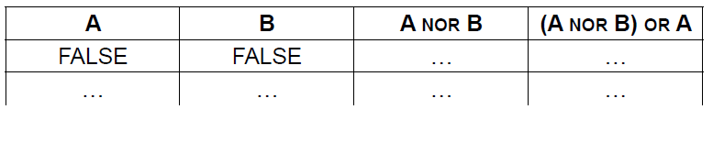

1. Construct a logic diagram for the Boolean expression

NOT A OR B AND C. [3]

1. A company produces industrial chemicals. One of the chemical processes is represented  
    by the following logic diagram.

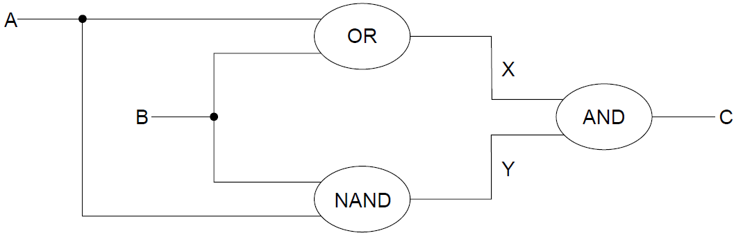

1. (i) Construct the truth table corresponding to this diagram. [3]  
     
     
     
     
     
     
     
     
     
     
     
     
   (ii) Identify the single logic gate that is equivalent to this diagram. [1]
2. Outline how truth tables can be used to test that any two logic diagrams are   
   equivalent. [2]

1. One of the functions of an operating system is memory management.  
     
   Describe how this function prevents the system from crashing when more than one program is   
   run at the same time. [2]
2. Define the term bit. [1]
3. The following number is stored as an 8 bit 2’s complement binary number. What number does it represent in decimal?

11111011

1. An application package used in an office includes a word processor. A secretary uses the

word processor to create a text file.

1. Describe how a spellchecker checks whether a word in a text file is correctly spelt

or not. [2]

The text file is automatically saved at regular periods while being edited.

1. State **one** advantage of this feature. [1]
2. Identify **two** additional features of a word processing package that could be useful for   
   this office. [2]
3. Outline the purpose of **one** application software package other than a word processing package that could be used in this office. [2]